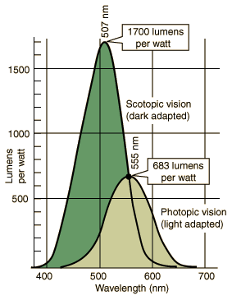 | Luminous Efficacy  The curves represent the spectral luminous efficacy for human vision. The lumen is defined such that the peak of the photopic vision curve has a luminous efficacy of 683 lumens/watt. This value for the scotopic peak makes the efficacy the same as the photopic value at 555 nm.  The scotopic vision is primarily rod vision, and the photopic vision includes the cones.  The response curve of the eye along with the spectral power distribution of a luminous object determine the perceived color of the object.
  Efficacy Tables
  Examples
  Why is a candle flame yellow?

Wavelength  λ (nm) | Photopic Luminous Efficacy V_{λ} | Photopic Conversion lm/W | Scotopic Luminous Efficacy V_{λ} | Scotopic Conversion lm/W
380 | 0.000039 | 0.027 | 0.000589 | 1.001
390 | 0.000120 | 0.082 | 0.002209 | 3.755
390 | 0.000120 | 0.082 | 0.002209 | 3.755
400 | 0.000396 | 0.270 | 0.009290 | 15.793
410 | 0.001210 | 0.826 | 0.034840 | 59.228
420 | 0.004000 | 2.732 | 0.096600 | 164.220
430 | 0.011600 | 7.923 | 0.199800 | 339.660
440 | 0.023000 | 15.709 | 0.328100 | 557.770
450 | 0.038000 | 25.954 | 0.455000 | 773.500
460 | 0.060000 | 40.980 | 0.567000 | 963.900
470 | 0.090980 | 62.139 | 0.676000 | 1149.200
480 | 0.139020 | 94.951 | 0.793000 | 1348.100
490 | 0.208020 | 142.078 | 0.904000 | 1536.800
500 | 0.323000 | 220.609 | 0.982000 | 1669.400
507 | 0.444310 | 303.464 | 1.000000 | 1700.000
510 | 0.503000 | 343.549 | 0.997000 | 1694.900
520 | 0.710000 | 484.930 | 0.935000 | 1589.500
530 | 0.862000 | 588.746 | 0.811000 | 1378.700
540 | 0.954000 | 651.582 | 0.655000 | 1105.000
550 | 0.994950 | 679.551 | 0.481000 | 817.700
555 | 1.000000 | 683.000 | 0.402000 | 683.000
560 | 0.995000 | 679.585 | 0.328800 | 558.960
570 | 0.952000 | 650.216 | 0.207600 | 352.920
580 | 0.870000 | 594.210 | 0.121200 | 206.040
590 | 0.757000 | 517.031 | 0.065500 | 111.350
600 | 0.631000 | 430.973 | 0.033150 | 56.355
610 | 0.503000 | 343.549 | 0.015930 | 27.081
620 | 0.381000 | 260.223 | 0.007370 | 12.529
630 | 0.265000 | 180.995 | 0.003335 | 5.670
640 | 0.175000 | 119.525 | 0.001497 | 2.545
650 | 0.107000 | 73.081 | 0.000677 | 1.151
660 | 0.061000 | 41.663 | 0.000313 | 0.532
670 | 0.032000 | 21.856 | 0.000148 | 0.252
680 | 0.017000 | 11.611 | 0.000072 | 0.122
690 | 0.008210 | 5.607 | 0.000035 | 0.060
700 | 0.004102 | 2.802 | 0.000018 | 0.030
710 | 0.002091 | 1.428 | 0.000009 | 0.016
720 | 0.001047 | 0.715 | 0.000005 | 0.008
730 | 0.000520 | 0.355 | 0.000003 | 0.004
740 | 0.000249 | 0.170 | 0.000001 | 0.002
750 | 0.000120 | 0.082 | 0.000001 | 0.001
760 | 0.000060 | 0.041 | 0.000000 | 0.000
770 | 0.000030 | 0.020 | 0.000000 | 0.000

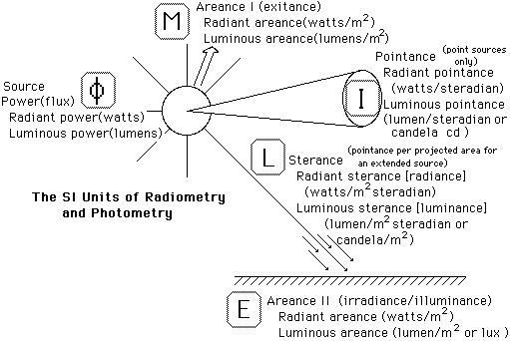

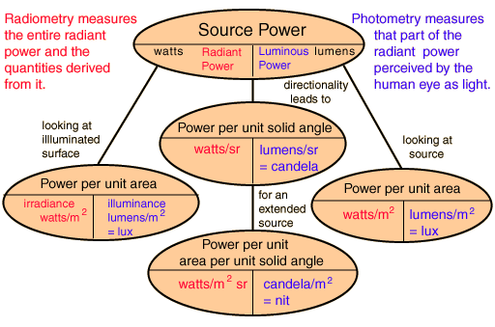

Power Per Unit Area of Surface
The power per unit area on an illuminated surface, sometimes called areance, is distinguished from the similar quantity for the source. In radiometry the surface areance may be called irradiance and luminous areance may be called illuminance. This is the quantity of practical importance in judging whether an area is lighted well enough for reading or other activities. The illuminance is measured in lux, but the older unit footcandle is still encountered.
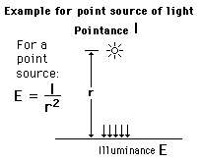
Illuminance E_{v} = Luminous intensity I_{v} /radius²
Haut du formulaire
A source with luminous intensity I_{v} = candela
at a perpendicular distance of r = m = ft
provides an illuminance of E_{v} = lux = footcandles.
Bas du formulaire

Surface Illuminance
The illuminance of a surface by a point source depends upon the pointance (intensity), the distance to the surface, and the angle of the surface. The illuminance is measured in lux, but the older unit footcandle is still encountered.
